**Camosun College**

**Electronics Department**

**ECET165 - LAB 1**

**INTRODUCTORY LABORATORY**

**The MPLAB Programming Environment**

**Reference:**

<http://www.microchip.com/mplab/mplab-x-ide>

<http://microchip.wikidot.com/mplabx:start>

**Objectives:**

Explore the MPLAB® X Integrated Development Environment (IDE) and write your first   
assembly language program.

**Procedure:**

**Install MPLAB X on your computer.**

**Note: Make an online logbook of all that you learn. Always log any errors.**

**Complete the questions near the end of tutorial and upload to D2L.**

**Part1 (if you are using a Lab computer go to part2):**

1. Install MPLAB X from the following link:

<https://www.microchip.com/en-us/development-tools-tools-and-software/mplab-x-ide>

1. Carefully follow the screen shots below to install the software: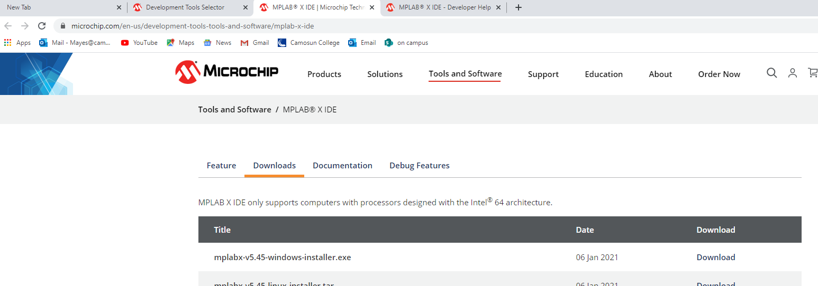

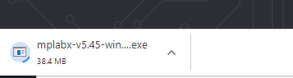

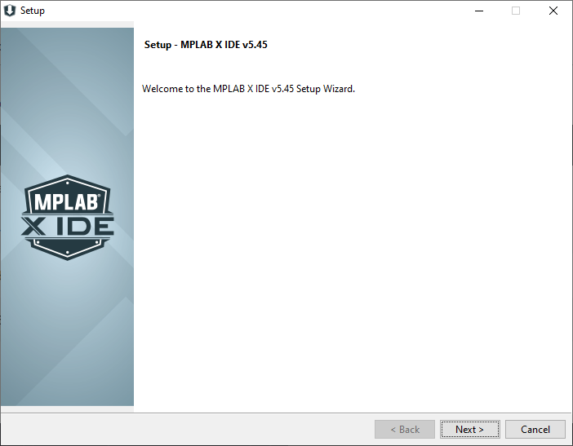

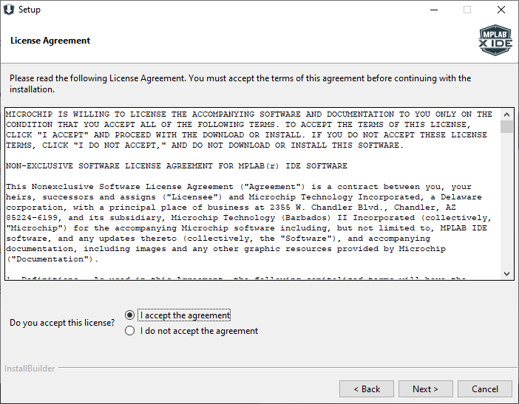

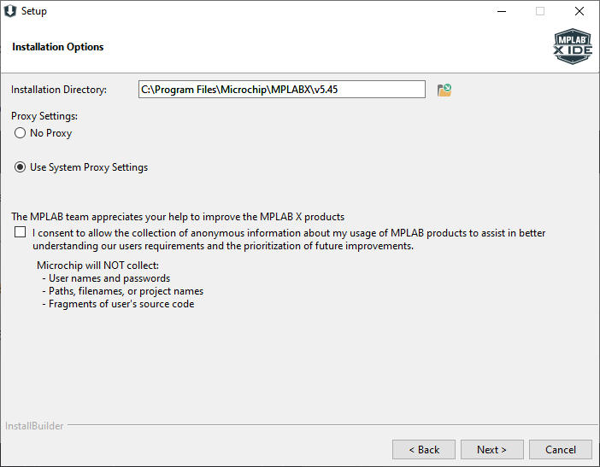

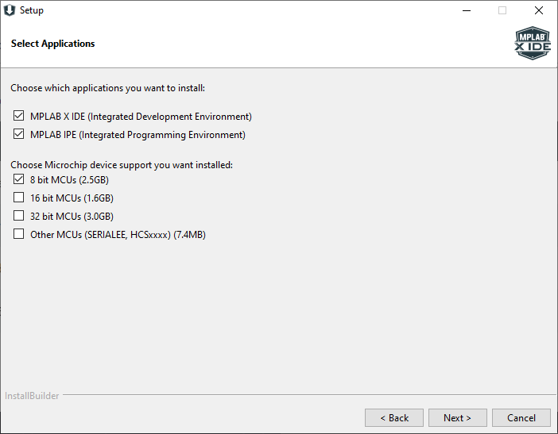

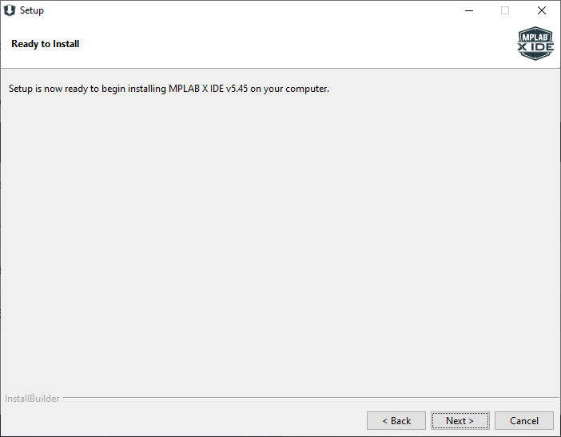

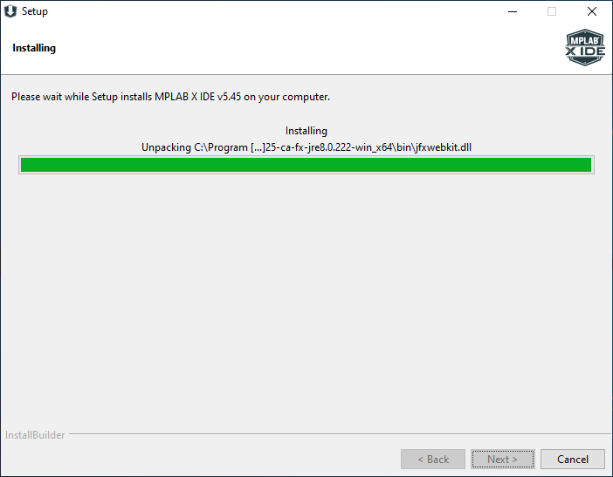

1. Now install the XC8 compiler: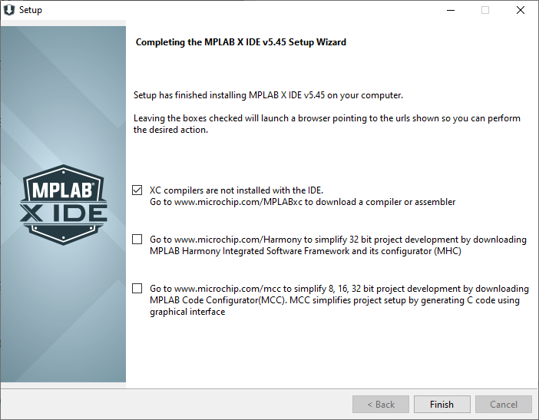
2. The following link should open when you click Finish:

<https://www.microchip.com/en-us/development-tools-tools-and-software/mplab-xc-compilers>

This is the version on the lab computers:

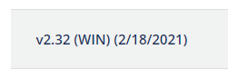

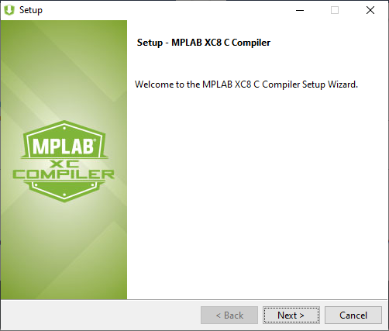

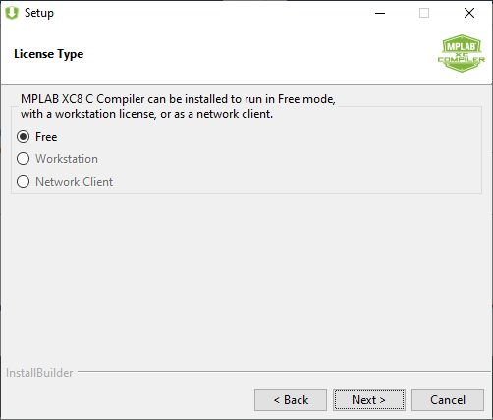

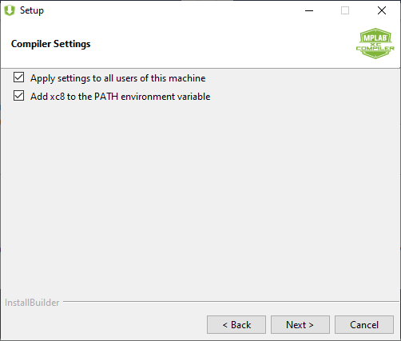

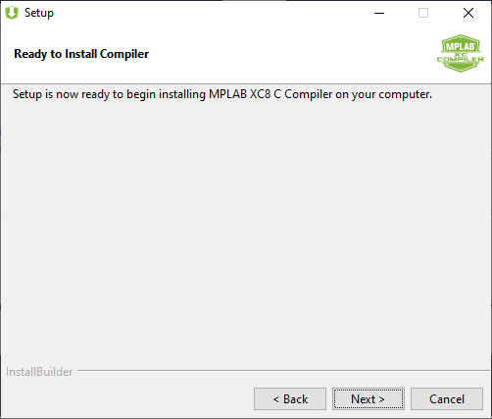

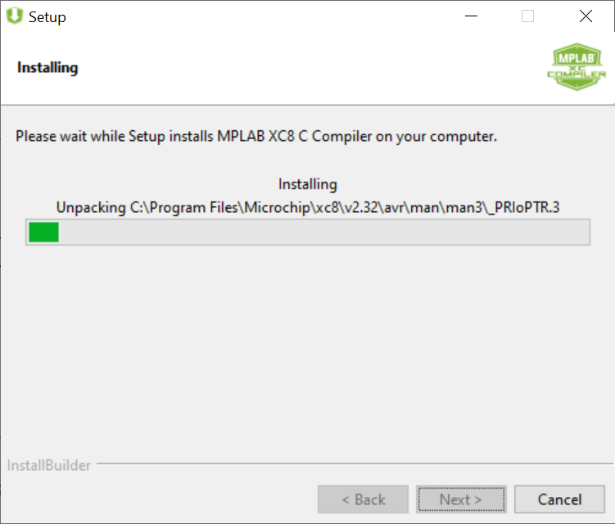

1. Click Next to install the free MPLAB XC8 compiler: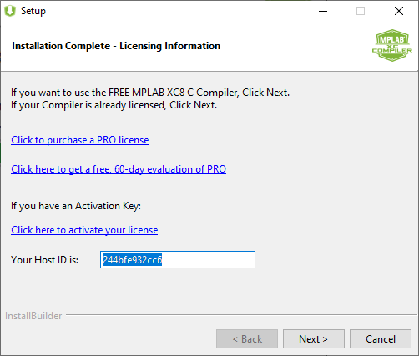

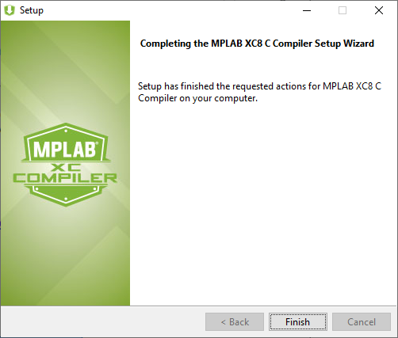

**Part2:**

1. Open the MPLAB X IDE:



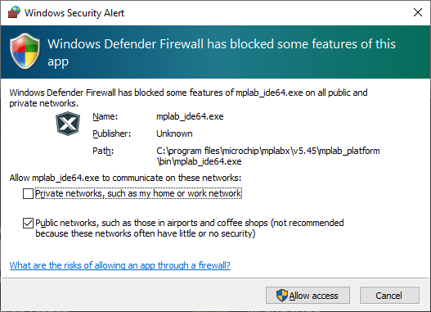

1. Click on **Create New Project**. Choose **Standalone Project**: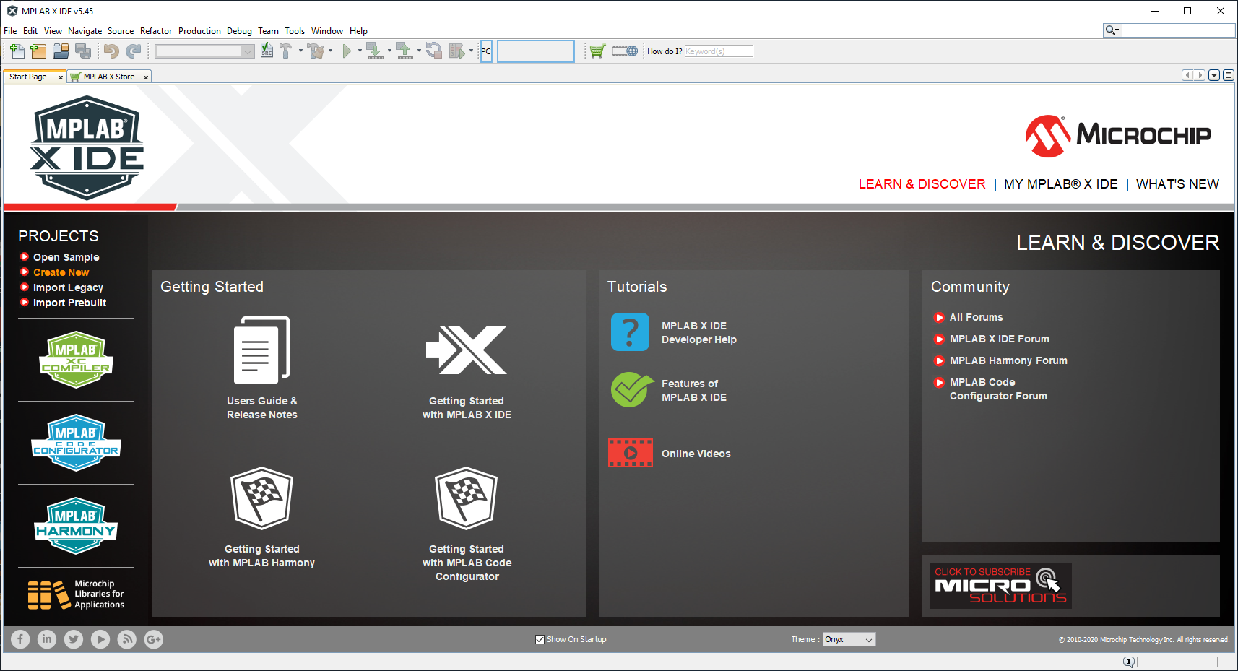

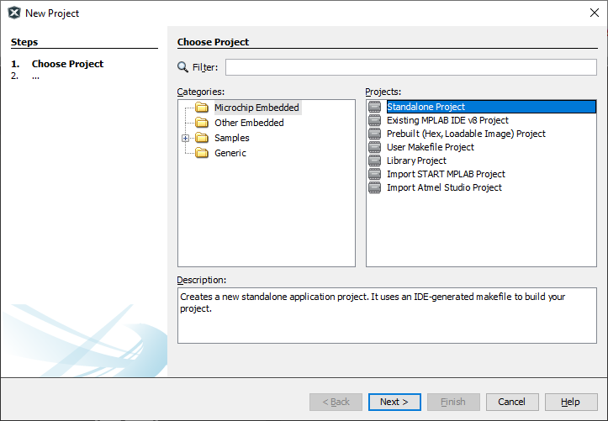

1. Select the device we have in the kit. First select the **Advanced 8-bit MCUs (PIC18)** to make it easier to find the correct chip and Select the **Simulator** as the tool: 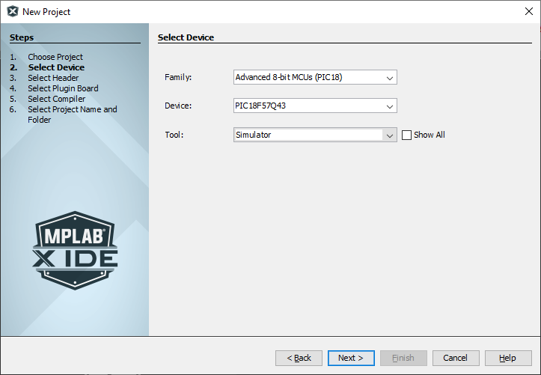
2. Select the pic-as assembler: 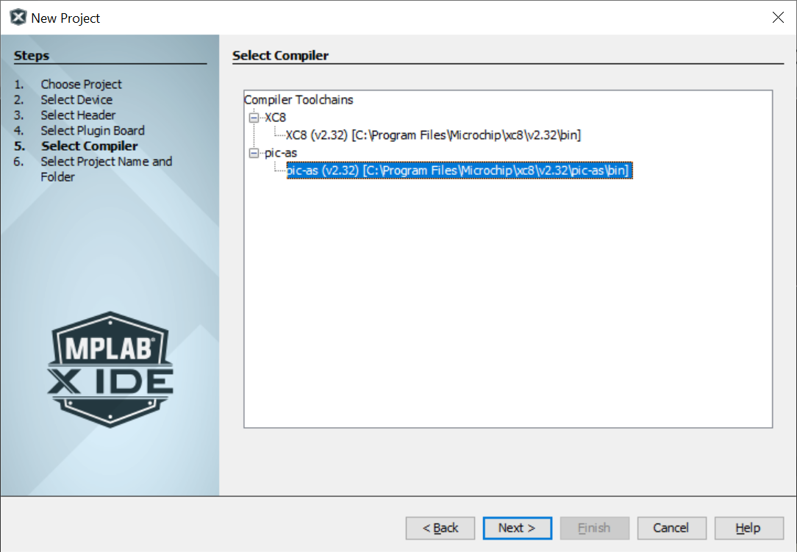
3. Enter a good project name. Use a name that tells what the program does: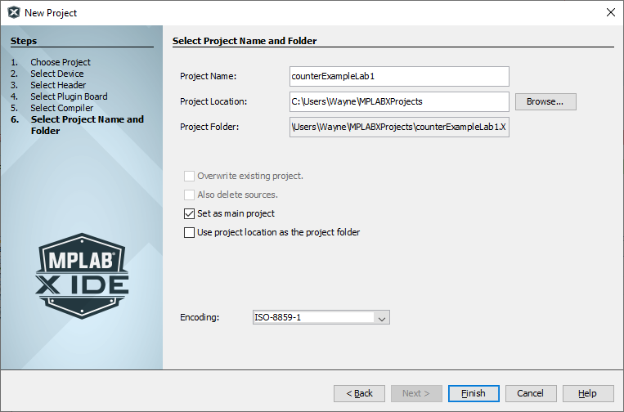
4. Right click on **Source Files**. Then highlight **New**, select **Other:** 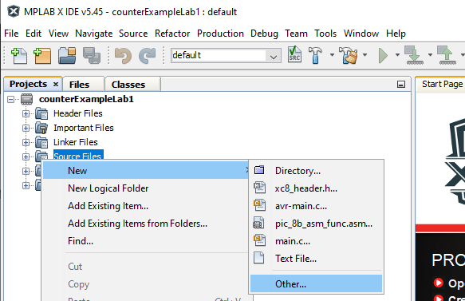
5. Choose the file type: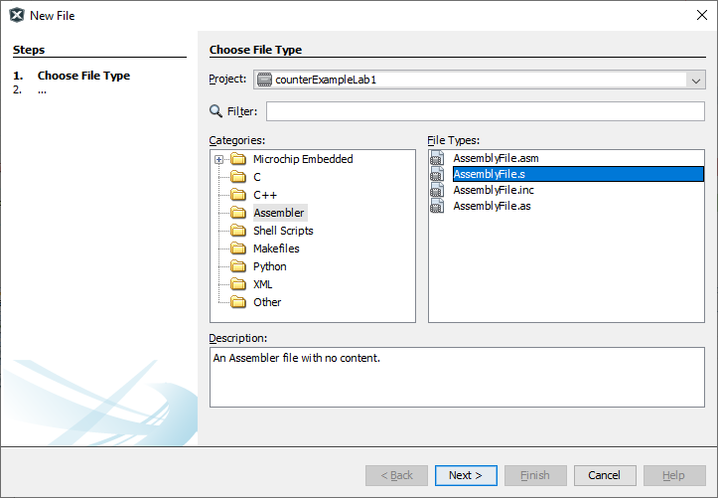
6. Enter the name of the assembly file: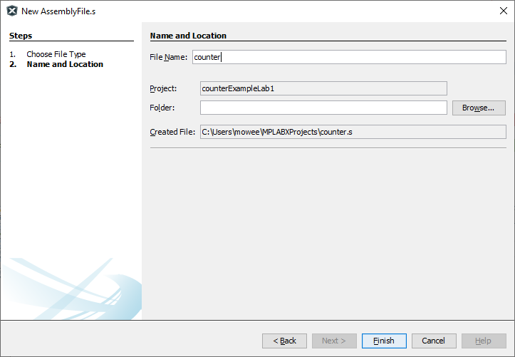
7. Your screen should look like this: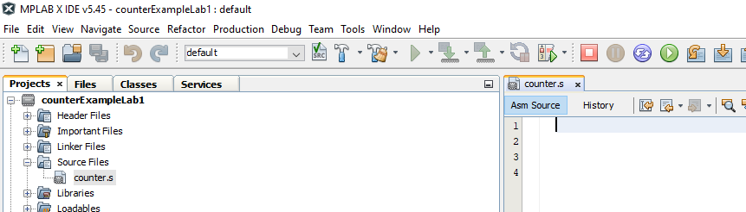
8. Type in the following code. Pay close attention to tabs and spacing: 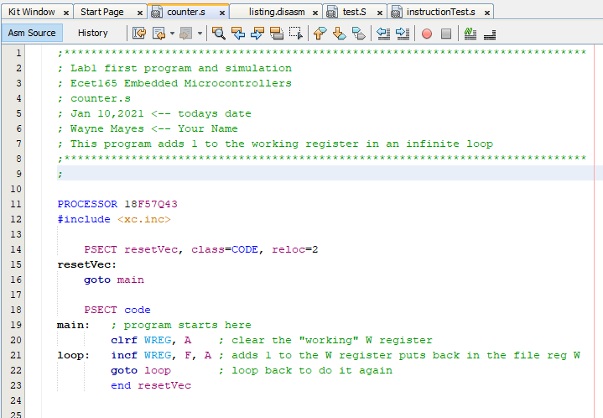
9. Save your code.
10. Build your project: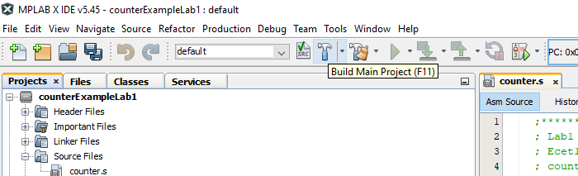

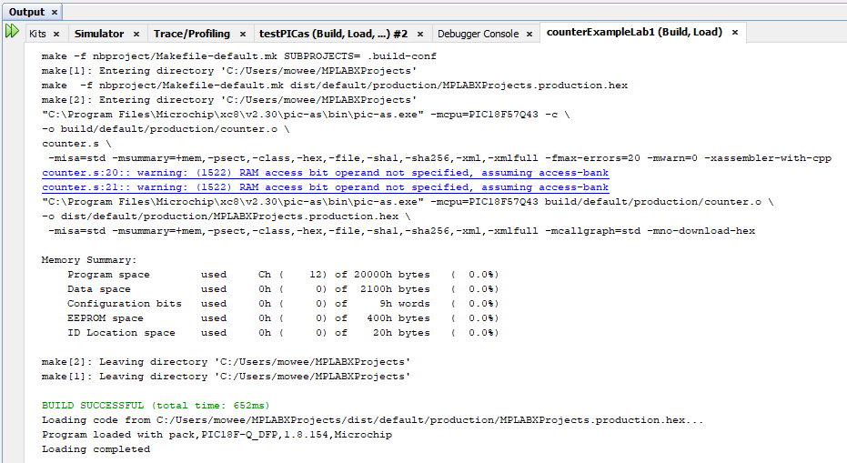

1. Take a look at Disassembly listing file: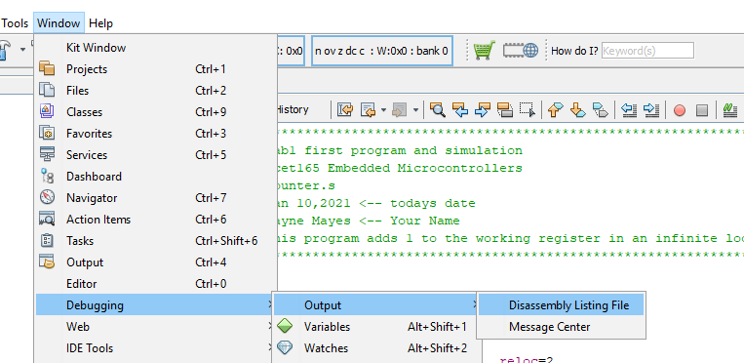
2. If you get this error, make sure you follow the instructions to build the symbol information: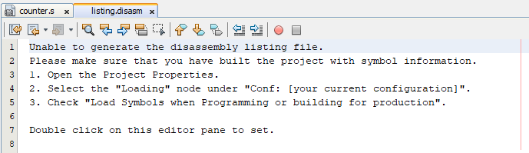
3. Select load symbols when programming: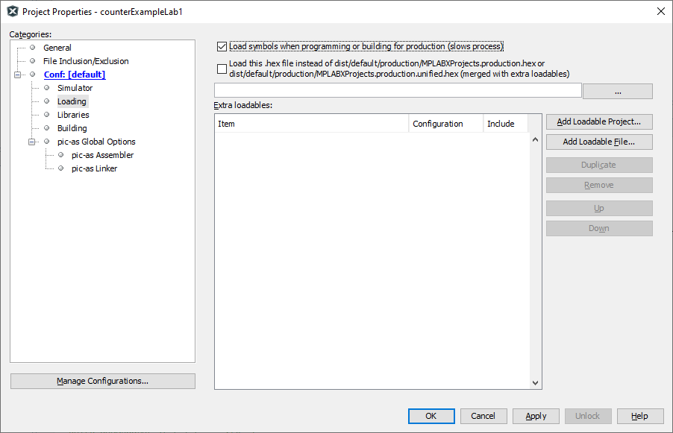
4. Build the main project: 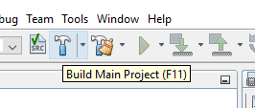
5. Now take a look at Disassembly listing file: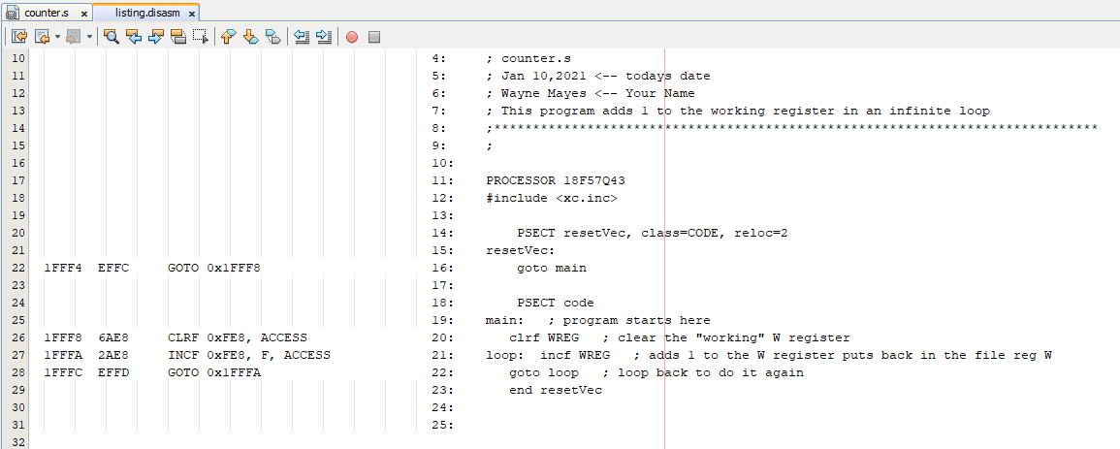
6. Debug the main project: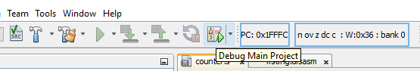
7. Now the program is running, but we cannot see the result: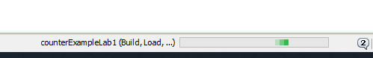
8. Pause the program: 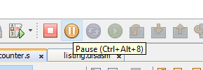
9. Right click to add a new watch variable: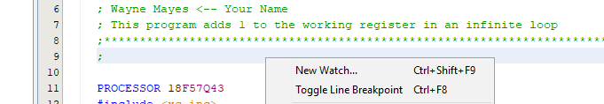
10. Type in the WREG and select SFR’s, or you can select from the SFR list: 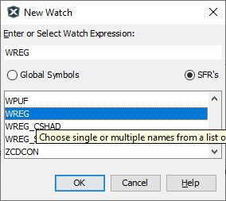
11. Mouse over each of the following buttons. Experiment with each of these buttons. Use google if necessary to help test and understand how each button works.



**Answer the following question in this word doc and upload to D2L.**

1. Research each of the following tools and explain their use in your own words?





























